Assignment -1 Create a job to deploy index.html in httpd
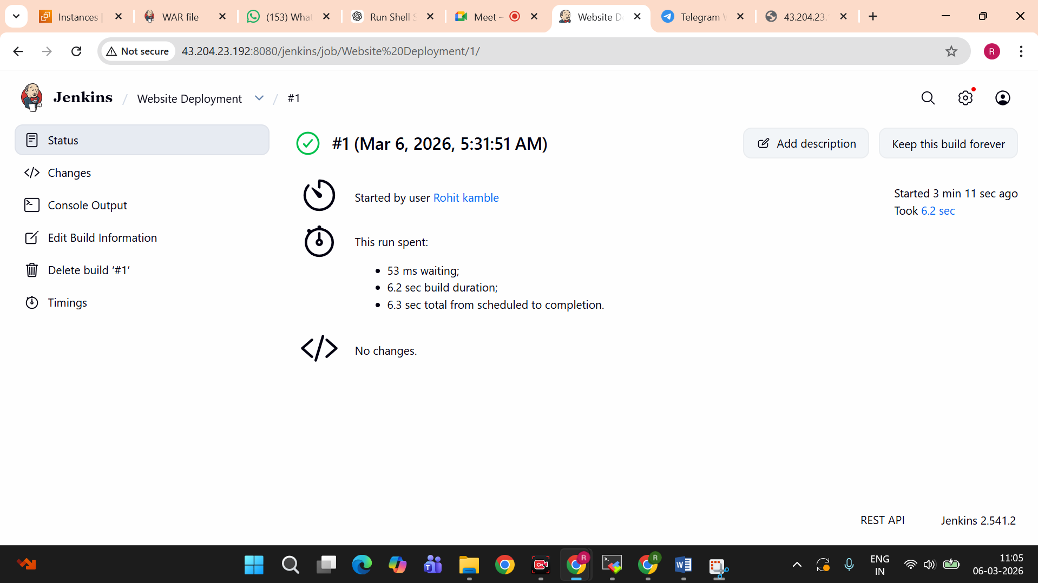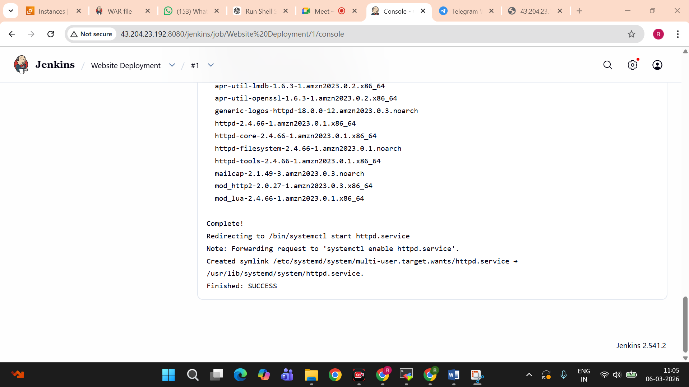
Schell Script-
#!/bin/bash
sudo -i
yum install httpd -y
service httpd start
echo "<H1>Sample Website</H1>" >> /var/www/html/index.html
chkconfig httpd on
cd /var/www/html/
chmod 777 index.html

